**Web Designing Assignment**

**Module (HTML) -1**

**From: Shivani Gohil To: Arpit kansara**

1. **Are the HTML tags and elements the same thing?**

**Ans**. No, HTML tags and ELEMENTS both are different from each other

**HTML tags are used to hold the HTML element and HTML element holds the content.**

Definition of html tag - HTML tags help web browsers convert HTML documents into web pages.

Elements - An HTML element is **a component of an HTML document that tells a web browser how to structure and interpret a part of the HTML document**. 

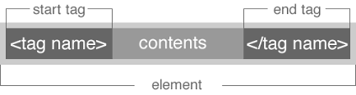

1. **What are tags and attribute in html?**

**Ans.**  Tag are used to mark up the start of an HTML element and they are usually enclosed in angle brackets.

An example of a tag is: <h1>.

Most tags must be opened <h1> and closed </h1> in order to function.

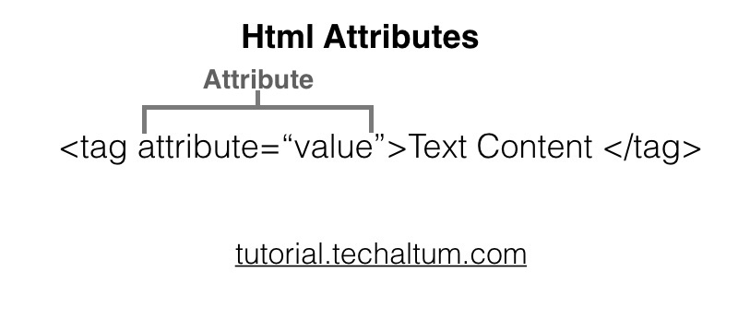



Attributes contain additional pieces of information. Attributes take the form of an opening tag and additional info is placed inside.

An example of an attribute is:

<img src="mydog.jpg" alt="A photo of my dog.">

1. **what are void element in html?**

**Ans.** There is a special group of elements that only have start tags and does not contain any content within it, these elements are called void elements.

**Example of such elements** are [<br>](https://www.geeksforgeeks.org/html-brgt-tag/), [<hr>](https://www.geeksforgeeks.org/html-hr-tag/), [<img>](https://www.geeksforgeeks.org/html-img-tag/), [<input>](https://www.geeksforgeeks.org/html-input-tag/), [<link>](https://www.geeksforgeeks.org/html-link-tag/), [<base>](https://www.geeksforgeeks.org/html-base-tag/), [<meta>](https://www.geeksforgeeks.org/html-meta-tag/),[<param>](https://www.geeksforgeeks.org/html-param-tag/), [<area>](https://www.geeksforgeeks.org/html-area-tag/), [<embed>](https://www.geeksforgeeks.org/html-embed-tag/), [<col>](https://www.geeksforgeeks.org/html-col-tag/), [<track>](https://www.geeksforgeeks.org/html-track-tag/), [<source>](https://www.geeksforgeeks.org/html-source-tag/) etc.

1. **what are html entities?**

**Ans.** An HTML entity is **a piece of text ("string") that begins with an ampersand (&) and ends with a semicolon ( ; )**.

|  |  |  |
| --- | --- | --- |
| Character | Entity | Note |
| & | &amp; | Interpreted as the beginning of an entity or character reference. |
| < | &lt; | Interpreted as the beginning of a tag |
| > | &gt; | Interpreted as the ending of a tag |
| " | &quot; | Interpreted as the beginning and end of an attribute's value. |

1. **What are different types of lists in HTML?**

Ans. HTML Lists help to display a list of information semantically. There are three types of lists in HTML:

Unordered list or Bulleted list (ul)

Ordered list or Numbered list (ol)

Description list or Definition list (dl)

**HTML Unordered List or Bulleted List**

Ans. In HTML unordered list, the list items have no specific order or sequence

HTML offers web authors three ways for specifying lists of information. All lists must contain one or more list elements. Lists may contain −

**<ul>** − An unordered list. This will list items using plain bullets.

**<ol>** − An ordered list. This will use different schemes of numbers to list your items.

**<dl>** − A definition list. This arranges your items in the same way as they are arranged in a dictionary.

## **HTML Unordered Lists**

An unordered list is a collection of related items that have no special order or sequence. This list is created by using HTML **<ul>** tag. Each item in the list is marked with a bullet.

* Beetroot
* Ginger
* Potato
* Radish

## **HTML Ordered Lists**

If you are required to put your items in a numbered list instead of bulleted, then HTML ordered list will be used. This list is created by using **<ol>** tag. The numbering starts at one and is incremented by one for each successive ordered list element tagged with <li>.

* Beetroot
* Ginger
* Potato
* Radish

**HTML Description List:**A description list is a list of terms, with a description of each term. The [<dl>](https://www.geeksforgeeks.org/html-dl-tag/) tag defines the description list, the <dt> tag defines the term name, and the <dd> tag describes each term. .

**HTML Description List:**A description list is a list of terms, with a description of each term. The [<dl>](https://www.geeksforgeeks.org/html-dl-tag/) tag defines the description list, the <dt> tag defines the term name, and the <dd> tag describes each term.

**Description list or Definition list (dl)**

A description list is a list of terms, with a description of each term. Lists in HTML are used for specifying particular information in list form

**Example:**

**coffee**

**a beverage made from roasted, ground coffee beans**

**a cup of coffee**

**a social gathering at which coffee is consumed**

**a medium to dark brown colour**

1. **What is the ‘class’ attribute in HTML?**

Ans. The class attribute **specifies one or more class names for an element**

. The class attribute **Class in html:**

The class is an attribute which specifies one or more class names for an HTML element.

The class attribute can be used on any HTML element.

The class name can be used by CSS and javascript to perform certain tasks for elements with the specified class name.

1. **What is the difference between the ‘id’ attribute and the ‘class’ attribute of HTML elements?**

**Ans. A Class name can be used by multiple HTML elements, while an ID name must only be used by one HTML element within the page**.

**HTML id Attribute:** The id attribute is a unique identifier which is used to specify the document. It is used by CSS and javascript to perform a certain task for a unique element. In CSS, the id attribute is written using # symbol followed by id.

**The class attribute** specifies one or more class names for an element.

The class attribute is mostly used to point to a class in a style sheet. However, it can also be used by a javascript to make changes to HTML elements with a specified class.

Applies to

The class attribute is part of the [Global Attributes](https://www.w3schools.com/tags/ref_standardattributes.asp), and can be used on any HTML element.

|  |  |
| --- | --- |
| **Element** | **Attribute** |
| All HTML elements | [Class](https://www.w3schools.com/tags/att_global_class.asp) |

1. **What are the various formatting tags in HTML?**

Ans. **HTML Text Formatting Elements**

|  |  |
| --- | --- |
| **Tag** | **Description** |
| [<b>](https://www.w3schools.com/tags/tag_b.asp) | Defines bold text |
| [<em>](https://www.w3schools.com/tags/tag_em.asp) | Defines emphasized text |
| [<i>](https://www.w3schools.com/tags/tag_i.asp) | Defines a part of text in an alternate voice or mood |
| [<small>](https://www.w3schools.com/tags/tag_small.asp) | Defines smaller text |
| [<strong>](https://www.w3schools.com/tags/tag_strong.asp) | Defines important text |
| [<sub>](https://www.w3schools.com/tags/tag_sub.asp) | Defines subscripted text |
| [<sup>](https://www.w3schools.com/tags/tag_sup.asp) | Defines superscripted text |
| [<ins>](https://www.w3schools.com/tags/tag_ins.asp) | Defines inserted text |
| [<del>](https://www.w3schools.com/tags/tag_del.asp) | Defines deleted text |
| [<mark>](https://www.w3schools.com/tags/tag_mark.asp) | Defines marked/highlighted text |

1. **How is Cell Padding different from Cell Spacing?**

Ans. Both Cellspacing and Cellpadding are the attributes that one can use in table formatting. They basically set those whitespaces in any given table cell. Thus, they form a significant part of a web document. Although both of them are attributes, there is a major difference between Cellpadding and Cellspacing in their functionality. We majorly use the Cellpadding for fixing the width present between a cell edge and the content that it contains. Conversely, we use Cellspacing for setting spaces between individual cells.

A user can measure the overall width of these given attributes with the use of pixels or percentages. If you need to adjust the space present between a text and the cell wall surrounding it (or the cells and the other cells within the table tag), then you can use attributes such as Cellspacing and Cellpadding.

**What is Cellpadding?**

It only associates with individual (single) cells.

Using Cellpadding, one can easily control the white space present between a cell border and the content present in it.

It is a very effective method.

It has a default value of 1.

One can create Cellpadding using the tag of HTML <table>.

Here, we set the type of attribute to *cellpadding*.

**What is Cellspacing?**

It associates with multiple cells- not just a single one.

Using Cellspacing, you can set the spaces between various cells.

It is comparatively less effective than the process of cell padding.

In this case, the spacing value by default becomes 2.

One can easily create Cell spacing by using the tag of HTML <table>.

Here, we set the type of attribute to *cell spacing*.

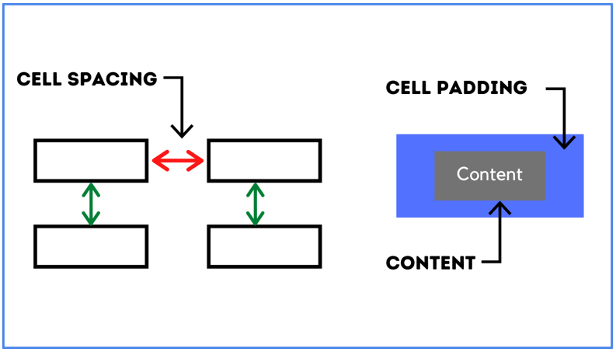

1. **How can we club two or more rows or columns into a single row or column in an HTML table?**

Ans. To merge cells in HTML, use the Col span and row span attribute.

The row span attribute is for the number of rows a cell should span,

The Col span attribute is for a number of columns a cell should span.

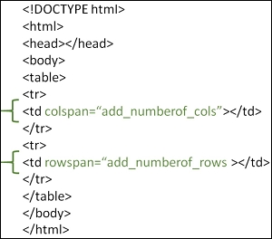

1. **What is the difference between a block-level element and an inline element?**

**Ans. Block elements:**They consume the entire width available irrespective of their sufficiency. They always start in a new line and have top and bottom margins. It does not contain any other elements next to it.

[**<h1>-<h6>**](https://www.geeksforgeeks.org/html-heading/)**:**This element is used for including headings of different sizes ranging from 1 to 6.

[**<div>**](https://www.geeksforgeeks.org/div-tag-html/)**:**This is a container tag and is used to make separate divisions of content on the web page.

[**<hr>**](https://www.geeksforgeeks.org/html-hr-size-attribute/)**:**This is an empty tag and is used for separating content by horizontal lines.

[**<li>**](https://www.geeksforgeeks.org/html-li-tag/)**:**This tag is used for including list items of an ordered or unordered list.

[**<ul>**](https://www.geeksforgeeks.org/html-ul-compact-attribute/)**:**This tag is used to make an unordered list.

[**<ol>**](https://www.geeksforgeeks.org/html-ol-compact-attribute/)**:**This tag is used to make an ordered list.

[**<p>**](https://www.geeksforgeeks.org/html-basics/)**:**This tag is used to include paragraphs of content in the webpage.

[**<table>**](https://www.geeksforgeeks.org/html-table-border-attribute/)**:**This tag is used for including the tables in the webpage when there is a need for tabular data.

**HTML 5 Semantic block elements:**

[**<header>**](https://www.geeksforgeeks.org/html5-semantics/)**:**This tag is used for including all the main things of the webpage like navbar, logos, and heading of the webpage.

[**<nav>**](https://www.geeksforgeeks.org/html5-semantics/)**:**This tag helps to navigate through different sections by including different blocks of hyperlinks in the webpage.

[**<footer>**](https://www.geeksforgeeks.org/html5-semantics/)**:**This contains all information about the authorization, contact, and copyright details of the webpage.

[**<main>**](https://www.geeksforgeeks.org/html5-semantics/)**:**The main content of the webpage resides in this tag.

[**<section>**](https://www.geeksforgeeks.org/html5-semantics/)**:**This is used separate different sections in the webpage.

[**<article>**](https://www.geeksforgeeks.org/html5-semantics/)**:**This tag is used to include different independent articles on the webpage.

[**<aside>**](https://www.geeksforgeeks.org/html5-semantics/)**:**This tag is used to mention details of the main content aside.

**Inline elements:**Inline elements occupy only enough width that is sufficient to it and allows other elements next to it which are inline. Inline elements don’t start from a new line and don’t have top and bottom margins as block elements have.

**Examples of Inline elements:**

[**<a>**](https://www.geeksforgeeks.org/html-links/)**:**This tag is used for including hyperlinks in the webpage.

[**<br>**](https://www.geeksforgeeks.org/html-brgt-tag/)**:**This tag is used for mentioning line breaks in the webpage wherever needed.

[**<script>**](https://www.geeksforgeeks.org/html-script-tag/)**:**This tag is used for including external and internal javascript codes.

[**<input>**](https://www.geeksforgeeks.org/html-input-tag/)**:**This tag is used for taking input from the users and is mainly used in forms.

[**<img>**](https://www.geeksforgeeks.org/html-img-tag/)**:**This tag is used for including different images in the webpage to add beauty to the webpage.

[**<span>**](https://www.geeksforgeeks.org/span-tag-html/)**:** This is an inline container that takes necessary space only.

[**<b>**](https://www.html.am/html-codes/text/html-bold.cfm)**:** This tag is used in places where bold text is needed.

[**<label>**](https://www.geeksforgeeks.org/html-label-tag/)**:**The tag in HTML is used to provide a usability improvement for mouse users i.e, if a user clicks on the text within the <label> element, it toggles the control.

**12)How to create a Hyperlink in HTML?**

Ans. To make a hyperlink in an HTML page, **use the <a> and </a> tags**, which are the tags used to define the links. The <a> tag indicates where the hyperlink starts and the </a> tag indicates where it ends. Whatever text gets added inside these tags, will work as a hyperlink. Add the URL for the link in the <a href=” ”>.

**13)What is the use of an iframe tag?**

Ans. Iframes in HTML are nothing but inline frames used as an HTML document to add another HTML document into it. It’s mostly used in web pages or [web development processes](https://www.educba.com/career-in-web-development/) to include other content through another source like advertisements on that webpage.

**14)What is the use of a span tag? Explain with example?**

Ans. HTML <span> tag is used as a generic container of inline elements. It is used for styling purpose to the grouped inline elements (using class and id attribute or inline style).

The <span> tag does not have any default meaning or rendering.

The <span> tag can be useful for the following task:

To change the language of a part of the text.

To change the color, font, background of a part of text using CSS

To apply the scripts to the particular part of the text.

Example

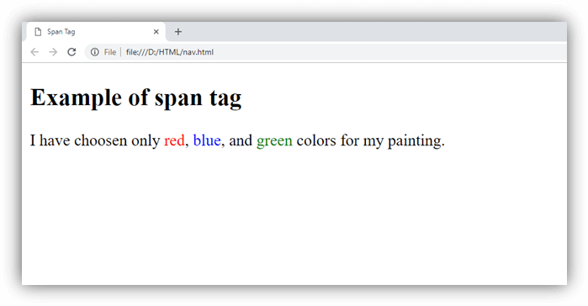

**15)How to insert a picture into a background image of a web page?**

Ans. In the body tag, specify a background image in the attribute by passing the URL of the image or location path.

<style>

Body {

Background-image:url (" URL of the image ");

}

</style>

**16)How are active links different from normal links?**

Ans. Links are categorized into three types. Typically a Link is displayed in three different colours based on the usage.

Normal links (Unvisited links)

Visited links

Active links

The following example shows the basic example for Normal Link (Unvisited Link). If you want to create a link to go to “https://www.abcd .org/“, you can get the normal link through this code. The default color is blue color and underlined but you can apply your own custom styling according to the application’s need.

**Visited Link:**In example 1, If you click on the link shown above and again go back to the link page, you can now see the link is in purple colour and underlined. It shows that the user has visited this link before. You can do your own custom styling using visited selector. In the above output, notice the visited link after going back from the home page.

**Active Link:**In example 1,If you left or right-click any one of the links Visited or Unvisited, it will turn into Red and Underline. Active Links shows that the browser is in the process to load a new resource.  You can do your own custom styling using[CSS:active selector](https://www.geeksforgeeks.org/css-active-selector/). In the above output, notice the active link on right-click of the link.

**17) What are the different tags to separate sections of text?**

Ans. There are three tags used to separate the texts. I.e Usually <br> tag is used to separate line of texts. Other tags are<p> tag and <blockquote> tag.

**18) What is SVG?**

**Ans.** Scalable Vector Graphics (SVG) is **a Web graphics language**

SVG stands for Scalable Vector Graphics

SVG is used to define graphics for the Web

SVG is a W3C recommendation

The HTML <svg> Element

The HTML <svg> element is a container for SVG graphics.

SVG has several methods for drawing paths, boxes, circles, text, and graphic images.

**19) Difference Between HTML and XHTML**

Ans. Most of the static web pages are based on HTML. When HTML is integrated with CSS, the web page becomes more presentable with background colours, images etc. It is also important to make the web page dynamic. A new page should open when a button is clicked. After entering the details in the form, the form validation should be performed. Those are some examples of dynamic behaviour in a web page. Javascript can be used to make the web page interactive. Generally, HTML, CSS and javascript work together in web development.

**What is HTML?**

HTML is short for Hypertext Markup Language. It is used to create websites and web applications. Let’s break it down, so we understand the name better:

* Hypertext: Hypertext refers to the “text wrapped within a text.” It is very similar to hyperlinks and contains an underlying text that, when clicked, redirects to a new webpage.
* Markup language: A markup language is not necessarily a programming language. Instead, it is used to apply formatting and layout to a simple text document. This leads to more interactive and dynamic text content.

**What is XHTML?**

There are many versions of HTML. The HTML 4 requires more computing power to take average HTML page and render it in a coherent and consistent manner. Therefore, the XHTML was introduced. XHTML stands for Extensible Hyper Text Markup Language. XHTML is not extensible. It is based on XML. The XML is similar to HTML, but it is designed to describe data. Unlike the HTML tags, the XML tags are not predefined. Therefore, the programmer can write the tags according to the application.

The main objective of developing XHTML was to develop to help the programmer to transfer from HTML to XML. XHTML is a descriptive markup language which works similar to HTML while handling data organization well. The first document type in the XHTML family is XHTML 1.0. XHTML is more similar to HTML 4.01. It sticker than HTML. It provides more precise standards and specifications for the website to understand data and to transmit them.

**Key Difference Between HTML and XHTML**

All the XHTML documents should start with the documents declaration at the top. All the attributes and the tag names should be in simple letters. It is necessary to nest all the tags properly. The attribute values are included inside quotes. Those are few facts to consider when writing XHTML files.

Overall, the XHTML is useful to make the web pages more likely to be compatible with present and future web browsers and to render accurately. XHTML makes easier to maintain and format for a long period of time. Even though the XHTML provides more precise standards to understand the data; one drawback is that it is harder to debug.

**20) What are logical and physical tags in HTML?**

**Ans.** Physical and Logical tags are used in HTML for better visibility and understanding of the text by the user on the web page. However, both tags differ from each other as suggested by their names.

**Logical tags:**  
Logical Tags are used in HTML to display the text according to the logical styles. Following are the Logical tags commonly used in HTML.

**Logical Tags**

| Tag | Description |
| --- | --- |
| <abbr> | Defines an abbreviation |
| <acronym> | Defines an acronym |
| <address> | Defines an address element |
| <cite> | Defines citation |
| <code> | Defines computer code text |
| <blockquote> | Defines a long quotation |
| <del> | Defines text |
| <dfn> | Defines a definition term |
| <ins> | Defines inserted text |
| <kbd> | Defines keyboard text |
| <pre> | Defines preformatted text |
| <q> | Defines short quotation |
| <samp> | Defines sample computer code |
| <strong> | Defines strong text |
| <var> | Defines a variable |

**Physical Tags**

Physical Tags are used in HTML to provide actual physical formatting to the text. Following are the Physical tags commonly used in HTML.

**Physical Tags**

| Tag | Description |
| --- | --- |
| <b> | Defines **bold**text |
| <big> | Defines big text |
| <i> | Defines *italic*text |
| <small> | Defines small text |
| <sup> | Defines superscriptedtext |
| <sub> | Defines subscriptedtext |
| <tt> | Defines teletype text |
| <u> | Deprecated. Use styles instead |
|  |  |

Thank you